Making Waves Interactive Exhibit – Project Proposal

Context
The Queensland Maritime Museum is currently trying to increase visits from a teenage demographic.
The University of Queensland (UQ) has been approached for assistance with creating an interactive experience for their “Making Waves” exhibition. A previous group prototyped a boat simulator, driven by an old vessel’s wheel. The virtual boat would visit “nodes” on the water, which would begin to display pre-recorded stories from modern Australian maritime adventurers.
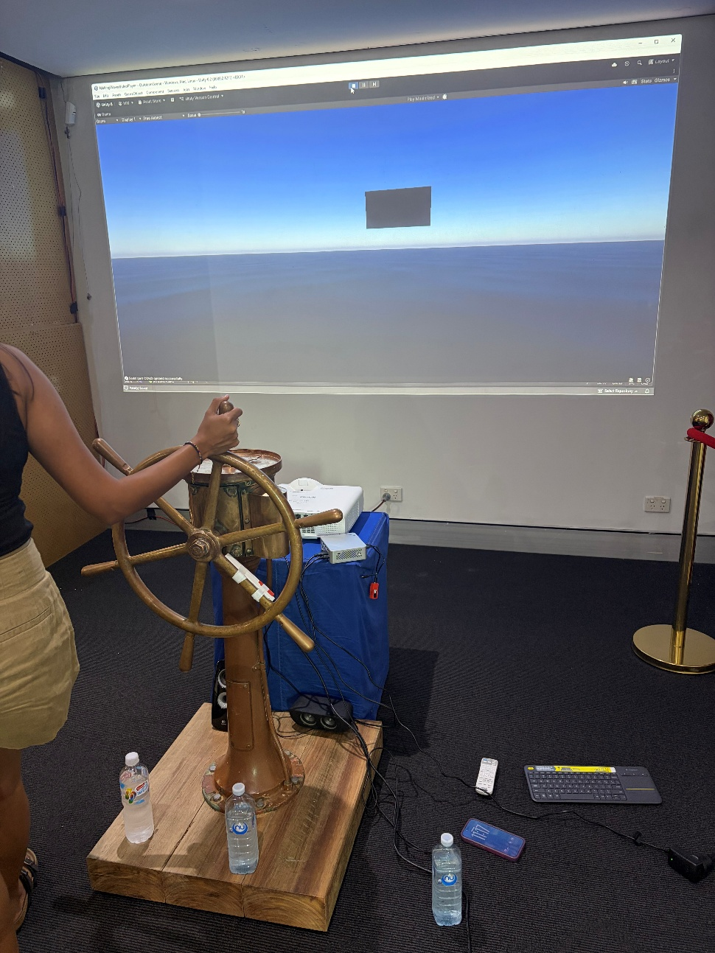
Figure 1: Current Interactive Prototype
Museum volunteers have noted that the current solution is a solid concept. However, it has had issues with reliability and consistent operation.

Objectives
- Increase interest from teenagers in maritime history, through development of an interactive experience for the “Making Waves” exhibition.
- Complete course requirements for the CSSE4011 “Final Project” assignment.

Deliverables
- Deliver as proof-of-concept in compliance with CSSE4011 course requirements.
- Deliver a finalised, one-off interactive exhibit to the Maritime Museum.
- Technical documentation around the design of the device, for future designers to perform extension work.
- Fact sheets, written in non-technical language, for museum volunteers to perform basic maintenance tasks (how to reboot, etc) on the system.

Proposed Solution
The course imposes a three-week deadline to complete the projects. Factoring in the additional time sink of a full study load and part-time work for all team members, we do not believe that we will be able to deliver a reliable product to the maritime museum in this timeframe.
Therefore, our solution will be delivered in two separate stages. In the first stage, a Minimum Viable Product (MVP) will be used primarily to comply with CSSE4011 requirements. We will demonstrate a simplified system, with similar functionality to the existing prototype. It will also serve as a demonstration system to collect feedback from Maritime Museum volunteers.
In addition, we also hope to present an alternative interactive experience, involving collectable RFID “messages” which can be exchanged for a small reward at the front desk. This is inspired from the story of Jessica Watson’s mother, Julie Watson, hiding little cards, notes, and other trinkets around the boat to keep her daughters spirits up when things got tough at sea. If this is achieved, we hope to demonstrate this to the volunteers and collect further feedback.
The second stage will involve iterating on the MVP based on volunteer feedback. This will take place after the completion of semester, likely beginning during the exam period. A focus towards software, electrical, and mechanical robustness will take place in this stage. We hope to work directly with the Maritime Museum to achieve exactly what they want.

Overall Design
The existing prototype has demonstrated the proof-of-concept of an interactive experience. Therefore, we will aim to reuse as many components from it as possible. Our proposed solution will involve reusing, where possible, the following items:
- Ship wheel
- Accelerometer on the wheel
- Speakers
- Projector + screen setup
- PC driving the projector
- Unity code on the PC

Stage 1: Minimum Viable Product
For the MVP, our primary goal is to demonstrate capability of interacting with the Bluetooth IMU, an external PC, and speakers. The interaction is depicted in Figure 2 below.
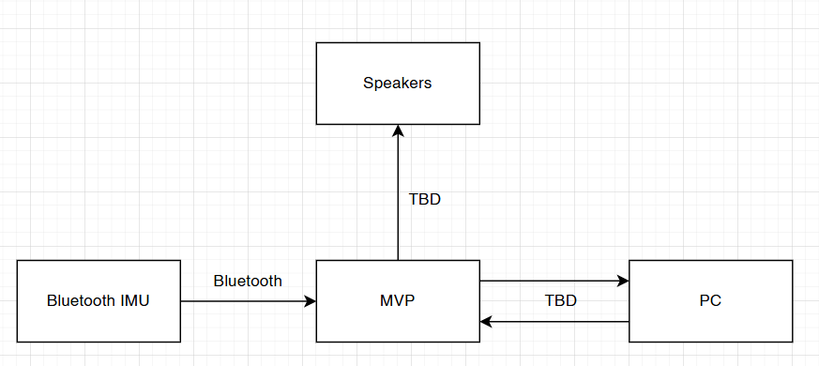
Figure 2: Hardware Communication Paths
The IMU will be mounted to a small-scale wheel, in leu of the full-sized boat wheel (which we believe we will struggle to carry around campus). IMU data will then be converted to a wheel velocity and sent to a computer over a standard protocol (TBD). Speakers will be driven based on wheel input to comply with the “actuation” criteria of the CSSE4011 specification.
A simplified GUI will also be developed, in leu of the existing Unity interface, to comply with UQ academic policies around plagiarism and with the CSSE4011 specification. This will display the position of the boat in a 2-dimensional, top-down view. We will demonstrate that the boat heading changes based on the position of the wheel.
As a stretch goal, we also hope to demonstrate an interactive RFID-based experience. Many RFID receivers or transmitters (analogous to the trinkets scattered around Jessica Watson’s boat) will be hidden around the demonstration space. When found, the user will “tap” these with a transmitter or receiver. If a user taps all available receivers/transmitter, then they can return to a “master receiver/transmitter”, which will count the number of scanned nodes. If all available nodes are found, a celebratory sound will play, and the user can collect a small reward.

Stage 2: Final Product
Technical details TBD, following Maritime Museum feedback on MVP(s).
A strong focus towards device robustness and usability will be considered here.

